CS 506 Web Programming – Python
PE09 Deep learning for text data
School of Technology & Computing (STC)
City University of Seattle (CityU)



Before You Start
- If you have questions about the programming exercise requirements, please ask a TA to clarify.
- If you are not sure what to do:
  - Consult the resources listed below.
  - If you cannot solve the problem after a few tries, ask a TA for help.

What and how to submit
- Write Python programs to complete the exercises below.
- Once you have solved all the given exercises, submit the source code to Brightspace.

Lab Tasks
- Write Python programs to complete the given tasks

Consider the following code (part 1) from the textbook that explained how Embedding layer works to process the sequence of texts.

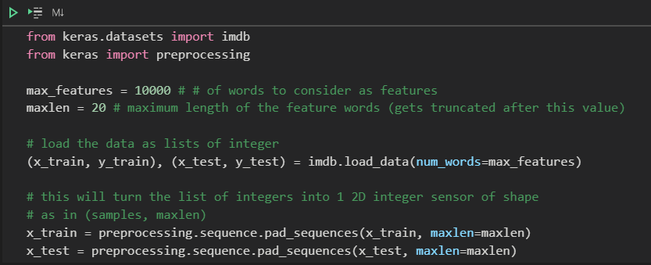

max_features is the parameter that runs on the dimension of features to be considered. For example, negativity, positivity, femininity, gender, age etc. maxlen is the parameter that truncates the input string. In other words, the initial value 10 only reads in 10 words from the imdb review data.
The following code (part2) now shows how to build a sequential network including Embedding layer with 8 layers followed by Dense layer with 1 layer. It uses sigmoid activation function. Validation is done on testing set (x_test, y_test) after the training. epoch size is initially set at 10.
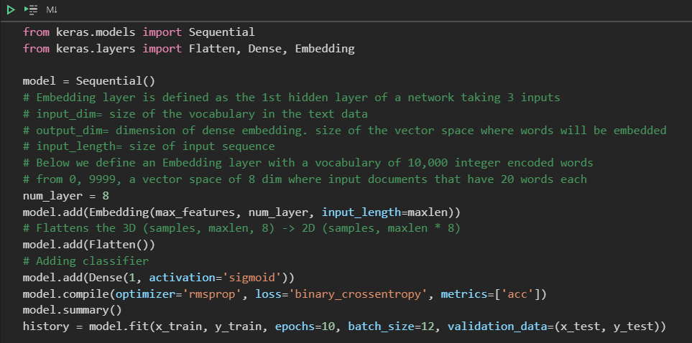

After you examine a different set of parameters (the script is attached in the BB link), answer the following questions:
- Increase the maxlen parameter (20, 60, 100, 140, 180, 220, 260) and document how the validation performance changes and include your conjecture. Choose one that has the best performance. If the performance shows no more improvement (performance saturation) choose the smallest value.
- Increase the num_layers (8, 16, 64, 128) and document how the validation performance changes and include your conjecture. Choose one that has the best performance. If the performance shows no more improvement (performance saturation) choose the smallest value.
- Examine 4 different activation functions (sigmoid, relu, tanh, and one other choice of yours after research). Summarize which one performed the best (no need to explain the reasons for this problem).

* In all your answers, add graph plots that support your argument and explanation.

